SAFETY
INFORMATION ON SAFETY
Travel agents make reservations, prepare trips and give useful information. However, there are some things which are checked as well, before making an agreement with the customer. This of course depends on the country one is visiting. The preparations will be different and more detailed if one is travelling to Afghanistan for example than travelling to the Netherlands.
The political situation of the country we are visiting is also an important matter. Another point that a travel agent should take into consideration is to supply customers with information for local people, addresses, phone of local embassy.
MORE ADVICE: If a traveller needs medication, then he/she should take as much as they think it will be enough for the period of their staying in the foreign country.

TOURISTS
“Tourists! Sometimes they don’t know what they are doing! They go straight to the beach on their first day and lie in the sun for hours. Then, they have to lie in bed for a week! It is better to sunbathe for just a quarter the first day.
Moreover, they go to the beach in the middle of the day, when the sun is burning down! The morning is better - or late afternoon.
And why do people swim immediately after a heavy meal? This can be dangerous. It is better to wait for two hours at least.
Another thing - people often take all their money and valuable things with them on the beach. This is nonsense. Unfortunately, there are lots of thieves about. It is better to have a credit card. It is also dangerous to carry documents (passports, tickets), on you. Much better to lock them in your hotel room.
Of course, all this is common sense at home when they go on holiday.”
TASK 1: Give some advice to tourists using the expressions below:
WAYS OF GIVING ADVICE
- I think you should
- I suppose you ought to
- It’s best to, it’s a good idea to
- You might
- You had better
- Why don’t you
- In my opinion
- I highly recommend
- The best advice I could give you would be /If I were you I would
ADVICE TO HILL-WALKERS
Walking in the mountains is a riskier business than many people think. If you go hill- walking leave yourself plenty of time. Carry some food with you. Listen to the weather forecast before you start out. Wear suitable clothing and boots. Take a map and compass. Ideally, go in a group of at least four-never go alone. Tell somebody where you are going-wear a bright-coloured anorak.
TASK 2: Which precautions are necessary and what advice would you give to someone who a. goes to a tropical island, b. goes driving across the Sahara desert.
For example: If you go on a camping trip you will experience a different lifestyle but you should carry only the necessary equipment. In my opinion a camera would be too heavy to carry. Why don’t you take a mobile phone that is also a camera?
TASK 3: If you were a flight attendant what would you advise a passenger who is afraid of flying? The notes below will help you to make full sentences.
Not be afraid / sleep well before travel / time to pack / time to go- airport - before take - off / relax - not drink / breathe deeply -when on plane / get exercise.
a. Don't be afraid-You shouldn’t be afraid

ADVICE TO TRAVELLERS
Do • carry your passport, your personal documents, your money and Travel Cheques in a safe place not just into a beach bag, or all in one pocket or wallet.
Don’t• carry a large amount of cash with you. You will not be able to take it back, if it is stolen or lost. Carry only enough cash to meet your day - to – day expenses. If you are staying in a hotel, hand any large sum of cash to the manager for safekeeping and ask for a receipt.
Do• always carry your ID or passport when cashing Travel Cheques. These should be in small banknotes of €5 and €10 to make things easier for your daily needs. Keep a note of the serial numbers in case of loss.
Don't carry your wallet in your back trouser pocket. Always carry it in an inside pocket. If you take off your jacket put your wallet in your trouser pocket.
Don’t leave your handbag, your hand luggage, or your briefcase unattended on railway platforms, waiting rooms, luggage racks or anywhere else.
Carry your camera, radio, portable computer with you and keep a note of the serial
number.
TASK 4: Rewrite some of the sentences above using the expressions you should, you ought to, it’s best to, it’s a good idea to, you might, you had better, why don’t you.
REQUESTS
AT THE TRAVEL AGENT’S
Travel Agent : Yes, can I help you?
Ketty : I'd like to visit India, but I don't know what I need to do before I leave.
Can you give me any good advice?
Travel Agent : Well, it's always a good idea to make your plan before you travel. But,
first, what kind of holiday do you want?
Ketty : Well, I want to know the cultural part of India. Temples, monuments,
dances…

TASK 5: You are planning a trip to Egypt and another one to Belgium. Choose from the list below what three things you will ask the travel agent about each destination and explain your choice.
Medicine, credit cards, water, vaccines=εμβόλια, national holidays, concerts, festivals, useful phones, special clothes, local customs.
Use: could you, would you please, would you mind….ing, do you think you could (possibly), I don’t suppose you could…..could you?
Exercise (Grammar)
Put the following verbs in the correct tense to complete the sentences: land, last, make a trip, protect, rescue, run out of, survive, raise the alarm, turn into, wave.
Last spring I decided to ___________ to a small village in the mountains for a holiday.
My trip started well enough, but it soon ___________ a nightmare. I got completely lost and I ___________ gas in the middle of nowhere. So I decided to take a short cut by continuing on foot across the mountains, but I fell and hurt my leg. I ___________ at some people on the road below, but they didn't take any notice, and then it started snowing. I ___________ myself from the cold by making a shelter from branches. I lit a fire and waited for someone to ___________ me. Luckily some hunters saw the smoke and _________. A few hours later a helicopter _________ nearby and I was taken to hospital.

Look at the following warning signs and match them with the write caption.

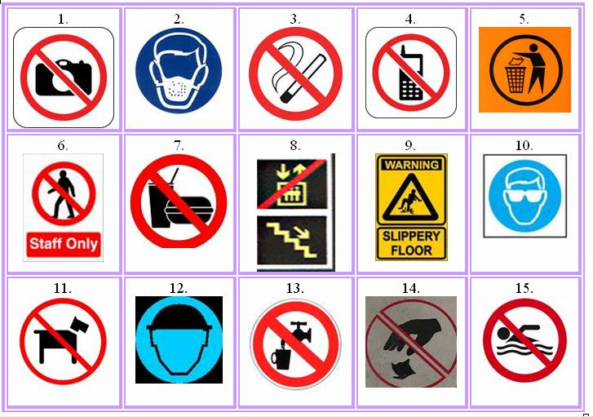
a) Wear a safety helmet.
b) Put your litter in the bin.
c) Don't take photos.
d) Don't drop litter.
e) Be careful. Do not fall down.
f) Do not drink.
g) Do not smoke.
h) Do not eat or drink.
i) Dogs are not allowed.
j) Wear an eye protection.
k) Do not use mobile phone.
l) Do not swim.
m)Wear a mask.
n) Do not enter.
o) Use the elevator.

