SOFT SKILLS
Read the list of personal qualities below. Check FIVE of your best personal qualities.
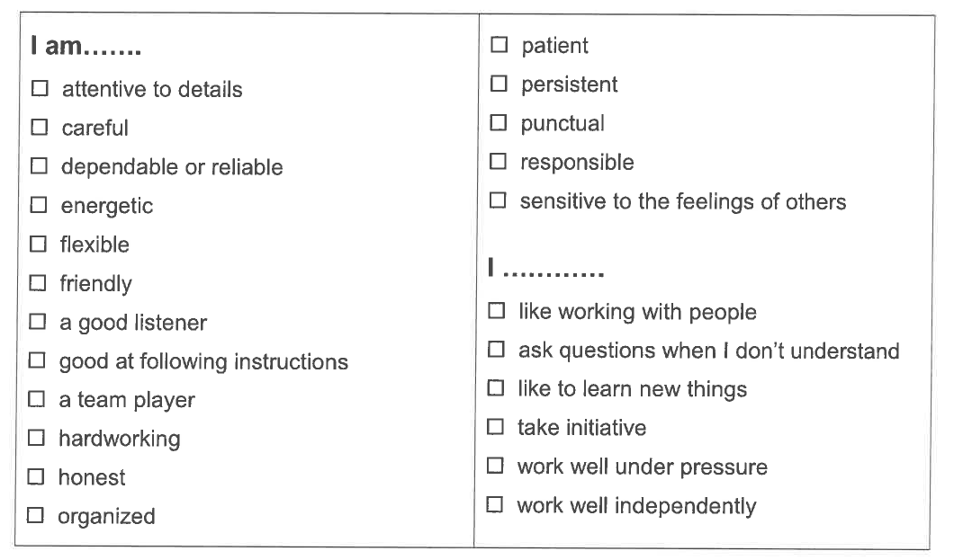
Read the employees statements below. Write the personal qualities that match the employees’ statements.
