1.- Complete the sentences with the words and phrases below.
aware delayed departure go abroad luggage overnight treacherous
- We stayed ___________________ in an expensive hotel. Unfortunately, we had to leave the next day.
- The ___________________ time is 15:00. However, we must be at the station early to buy the tickets.
- Most people are ____________________ of the importance of protecting our environment and that’s why they used public means of transport.
- The driver put all the ____________________ in the back of the taxi before he drove to the airport.
- My parents have decided they don’t want to _______________________ this year. We’re going to have our holiday close to home instead.
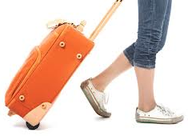
- That mountain road is _________________________. There have been many accidents on it this year.
- If your train is _______________________, it will leave late.

In recent years, airports have become very ¹ ___________________ (stress) place where passengers face long queues, delays and lost luggage. In addition, there now seems to be little ² ___________________ (differ) between the terminal of a ³ ____________________ (type) airport and a crowded, noisy shopping centre. But airports in some cities – including Paris, Amsterdam and San Francisco – offer travellers a quieter alternative: art museums. Some feature work by contemporary local ⁴ ___________________ (art), while others make ⁵ _____________________ (arrange) with major museums that allow them to borrow important works of art for special ⁶ _____________________ (exhibit).
⁷ ____________________ (inform) about airport museums is available online – so why not look it up before your next flight?

